# Overview

The Design Rationale is intended to provide designers and maker information about the design process and design decisions behind the development of the Switch Adapted Water Gun, a water gun stand that can be mounted on a wheelchair’s arm rest or the users’ arm for the users full range.

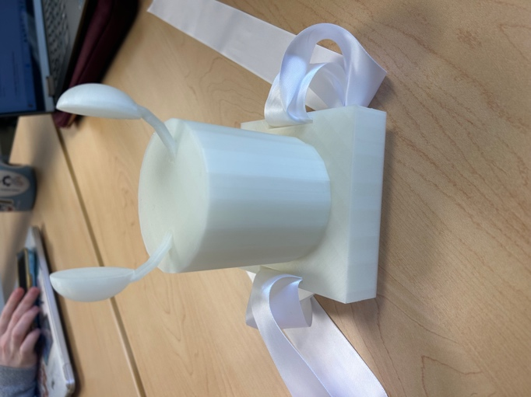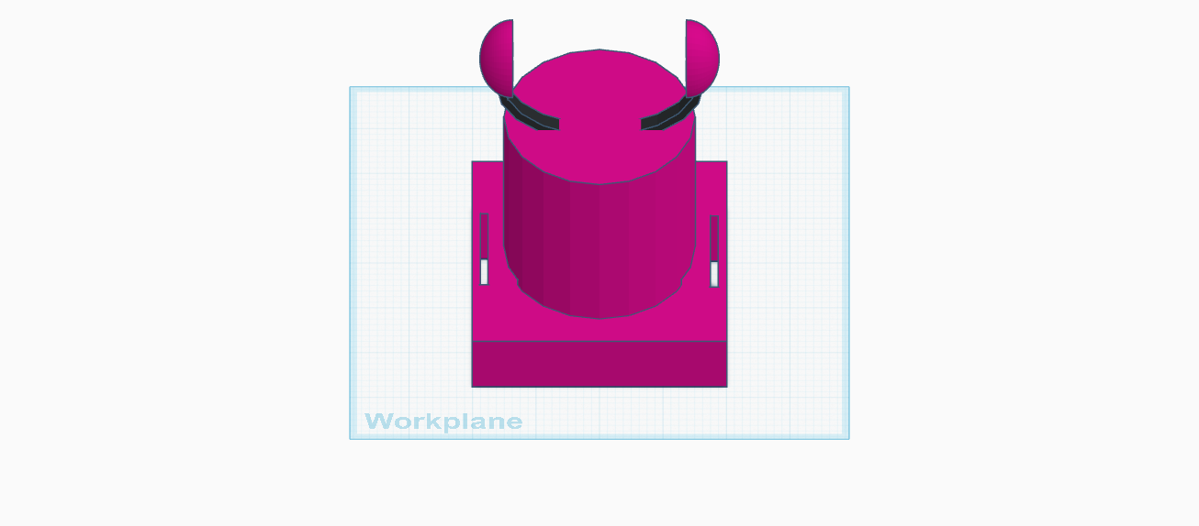

Figure 1 3D Printed Stand Figure 2 TinkerCad File

# Contents

Outline .......................................................................................................................................................... 2

Introduction .................................................................................................................................................. 3

Requirements ................................................................................................................................................ 4

Goals ......................................................................................................................................................... 4

Functional Requirements .......................................................................................................................... 4

Non-functional Requirement .................................................................................................................... 4

Constraints ................................................................................................................................................ 4

Research ........................................................................................................................................................ 5

Ideation ......................................................................................................................................................... 9

Conceptual Design .........................................................................................................................................

10

Prototyping ................................................................................................................................................... 11

Testing ........................................................................................................................................................... 12

Goals Met ……............................................................................................................................................. 13

Opportunities for Improvement ................................................................................................................. 14

# Introduction

Initially this was a group assignment for Macalester’s Human Computer Interaction (HCI) course where we had the goal of designing a water gun stand and functional trigger button for our water gun. We initially had no clue as to what the design should be, but in seeing how a speaker in the class talked about how many designs made for people with disabilities appeared as “boring” we decided to make something look a little bit more “fun”. Since our water gun was shark themed, we wanted to keep up with the water theme. There came the button design: a thunderstorm with a tornado underneath- Sharknado.

This water gun stand serves the purpose of allowing people with limited mobility to use the water gun. This is done by the way the stand can be mounted on arm rests as well as limbs it can be tied around. This allows the user to have as much range as their body or moving aide can allow. We also wired a functional button that works alongside with the water gun, this allows for the user to press the button if they are unable to use the trigger. This was all largely done in mind with people who have limited mobility, like cerebral palsy.

# Requirements

The goals and requirements outlined here can be used to assess if a device would meet the needs of a user, and determine when a design is sufficient for release.

## Goals

|  |  |
| --- | --- |
| G01 | Functional button |
| G02 | The stand should be able to stand upright if on the arm rest of the wheelchair |
| G03 | Adjustable for both arms and arm rest. |

## Functional Requirements

|  |  |
| --- | --- |
| F01 | Button and trigger must be functional |
| F02 | Water gun must be able to stay stable while on stand if on arm or arm rest |
| F03 | Adjustable strap to get mounted on arm or arm rest |

## Non-functional Requirement

|  |  |
| --- | --- |
| NF01 | Must be water themed |
| NF02 | Minimal assistance to place/wear |

## Constraints

<CONSTRAINTS ARE LIMITS ON THE DESIGN, SUCH AS COST, SIZE/WEIGHT, OR MATERIAL TYPES>

|  |  |
| --- | --- |
| C01 | Less than $5.00 USD to make of our own personal costs |
| C02 | Make it as light as possible |
| C03 | Basic PLA |

# Research

We listened to the personal accounts of class speakers, in-class learning on how to solder and 3D-print.

## Commercially Available Options

Options that can be purchased but not made by a maker.

|  |  |
| --- | --- |
| **Title / Name of device** | Tcovle Electric Shark Water Blaster |
| **Link** | <https://www.walmart.com/ip/Tcovle-Electric-Shark-Water-Blaster-Super-Squirter-Water-Fast-Fill-33-ft-Range-Soaker-Toys-Swimming-Pool-Beach-Party-Backyard-Gift-Kids-Age-3-Gray/5497230926?classType=VARIANT&from=/search> |
| **Author** | Tcolve |
| **License** | Walmart |
| **Cost** | $18.99 USD |

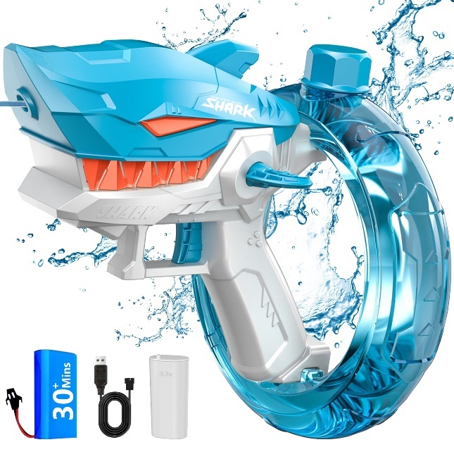

|  |  |
| --- | --- |
| **Requirements Met** | **Requirements Unmet** |
| Water themed  Minimal assistance to wear | Functional button  No stand  Adjustable straps for arm/arm rest use  Unable to stand on arm rest |
|  |  |
| **Title / Name of device** | Water Cannon |
| **Link** | https://www.thisiswhyimbroke.com/hose-powered-water-cannon/ |
| **Author** | N/A |
| **License** |  |
| **Cost** | $40.42 USD |

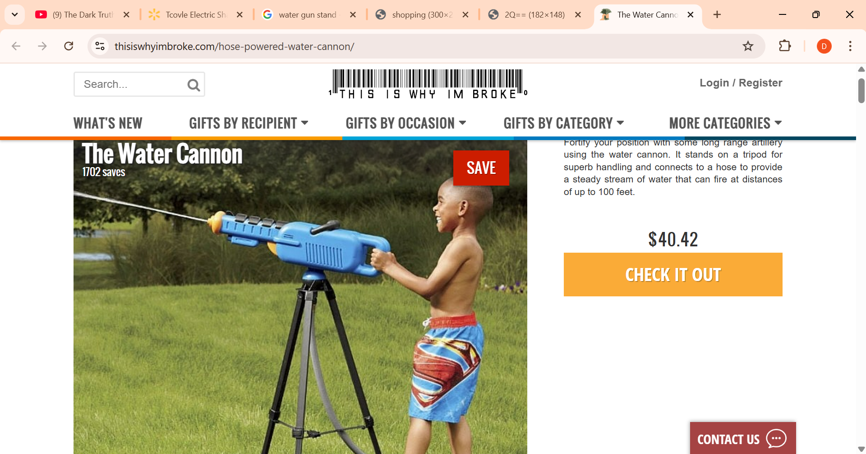

|  |  |
| --- | --- |
| **Requirements Met** | **Requirements Unmet** |
| Stand | Functional button  Price  Adjustable straps for arm/arm rest use  Unable to stand on arm rest |

|  |  |
| --- | --- |
| **Title / Name of device** | Water Gun Stand |
| **Link** | https://www.techbybrian.com/shop/p/water-gun-stand |
| **Author** | Brian |
| **License** | N/A |
| **Cost** | $25.00 USD |

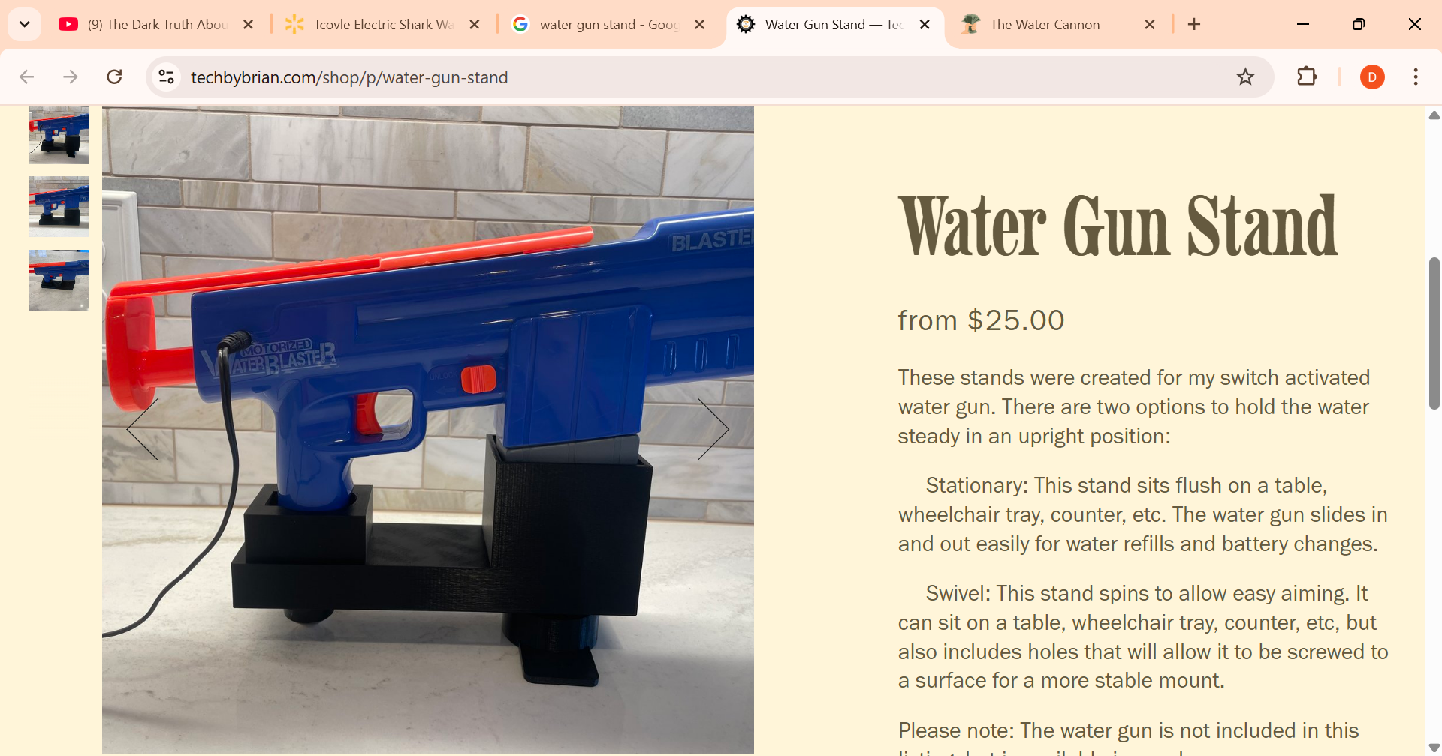

|  |  |
| --- | --- |
| **Requirements Met** | **Requirements Unmet** |
| Minimal assistance to wear  Stand | No button  No adjustable straps  Price |

*Useful Design Features*

Within these two examples, we are definitely going to use the Tcolve water gun since it is provided, but from what we saw in other examples there would very little we could take. When it comes to Brian’s version, he provides something we are hoping to achieve like the actual portability of it as well as how minimal need for assistance.

## DIY / Maker-Friendly Options

Options that can be made by a maker.

|  |  |
| --- | --- |
| **Title** | Water Pistol |
| **Link** | https://grabcad.com/library/water-pistol-1 |
| **Author** | Tom Craven |
| **License** | <DISTRIBUTION LICENSE, IF AVAILABLE> |
| **Cost** | Free |
| **Test Build (Y/N)** | N |
| **Add to Library (Y/N)** | N |

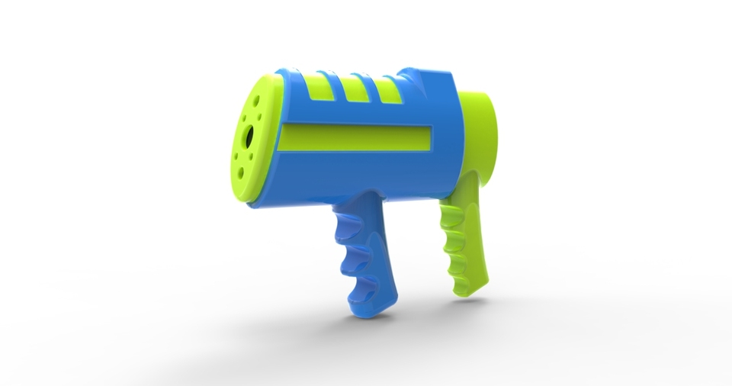

Small pistol that shoots water by pulling and pushing the gun.

|  |  |
| --- | --- |
| **Requirements Met** | **Requirements Unmet** |
| Trigger is functional  Less than $5.00 USD  Basic PLA | Not accessible for limited ability  Not able to be upright while on arm rest  Not strap adjustable for arms or arm rest  Not water themed |

*Useful Design Features*

It is free to 3D print and very minimal design.

# Ideation

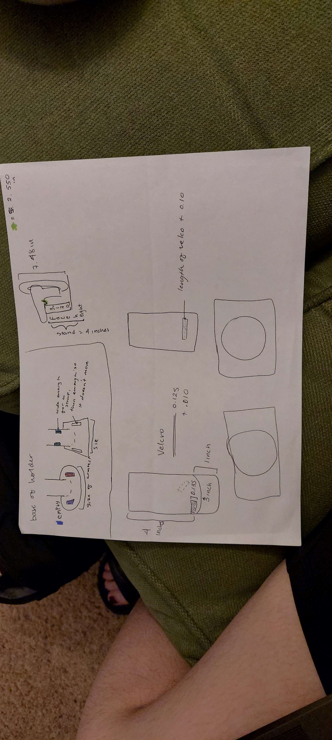What we know that we want is a stand that is just a single piece. That being said, the water gun holder and the stand must be connected. We like the idea of a flared base so that it can be comfortable for the user to not have sharp edges dig in their skin as well as being more stable when being placed on top of an arm rest.

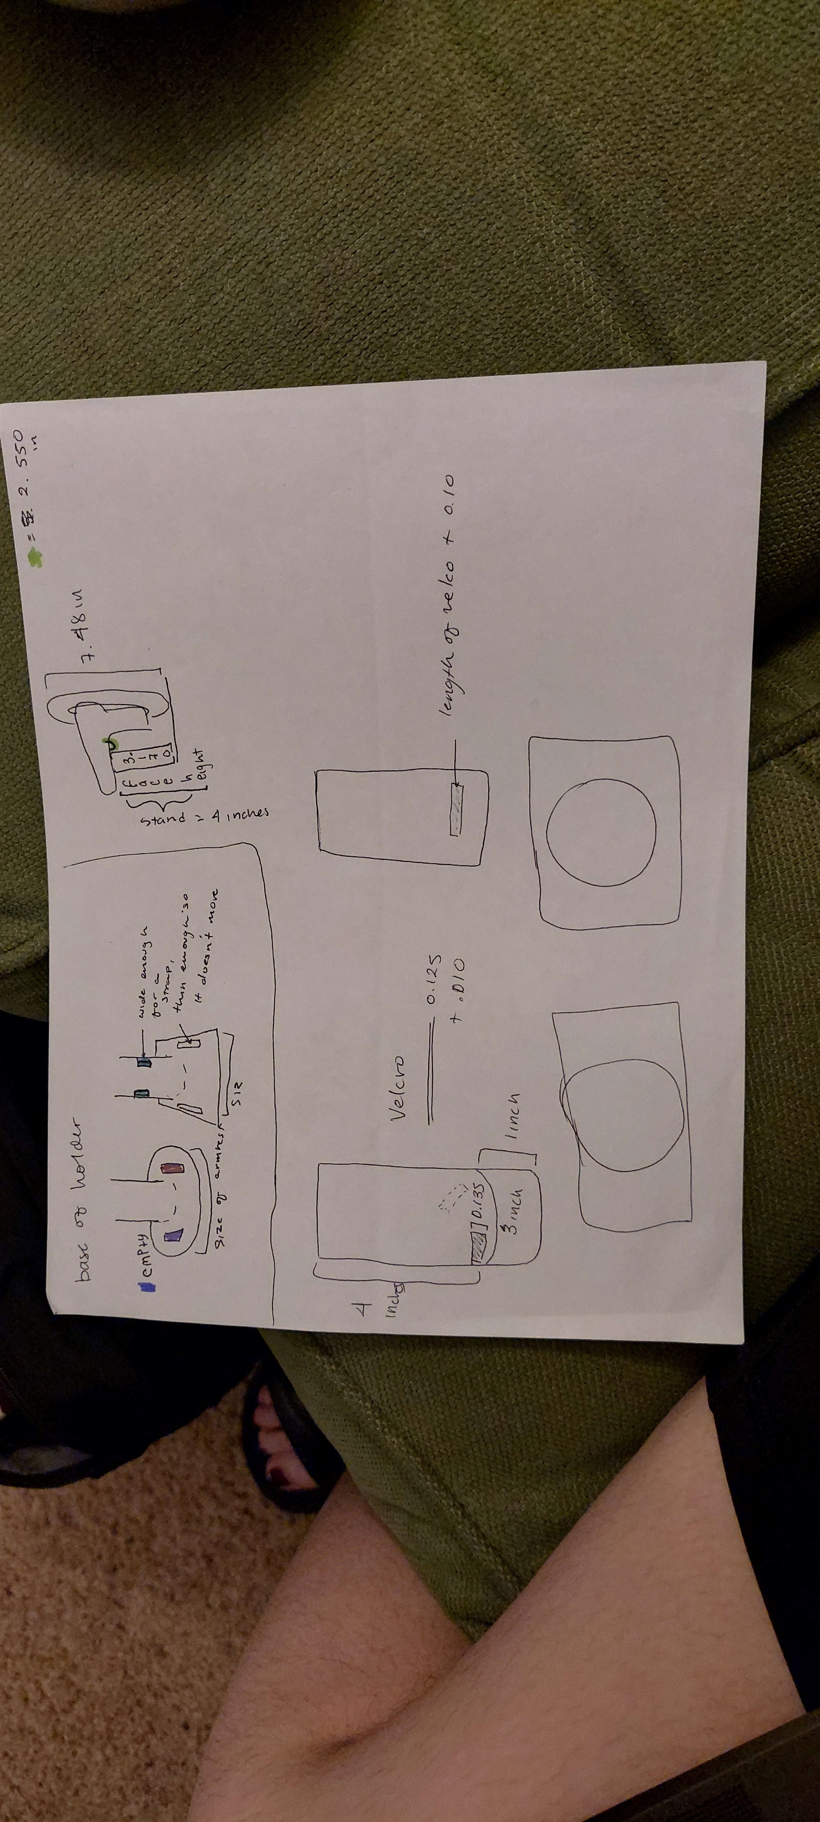

*Figure 3 Figure 4*

## Ideation Decisions

|  |  |  |
| --- | --- | --- |
| **Idea** | **Decision (Abandon, Modify, Proceed)** | **Justification** |
| <IDEA 1> | Abandoned | Expanded on in the next idea |
| <IDEA 2> | Proceed | Keeping the holes on the side and bottom |

** It is important to note that although we were aiming to have the 2nd idea, we resulted in having the 1st because of the inability of remove the supports in the cylinder

# Conceptual Designs

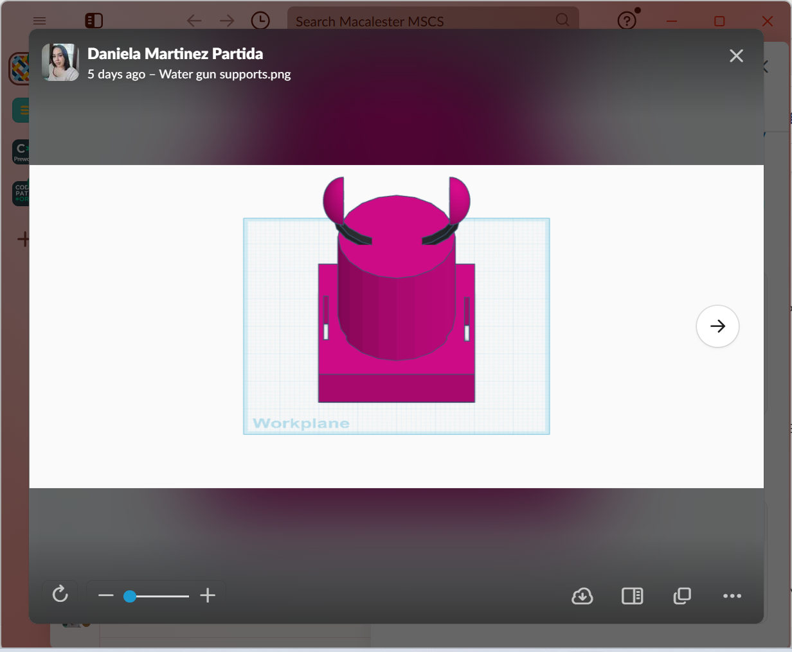We decided to work on the final idea, which was shown in Fig. 4. This design has holes for rope or Velcro straps to go through in both the square base and cylindrical stand. These portions are meant for the structure of the stand, hence it’s thickness and sturdy build. For the top portion of the stand which looks like a pair of headphones was built by two half spheres and a short hollowed out cylinder that was cut in half, and they serve the purpose of holding the actual water gun. The actual stand does not have any electrical components.

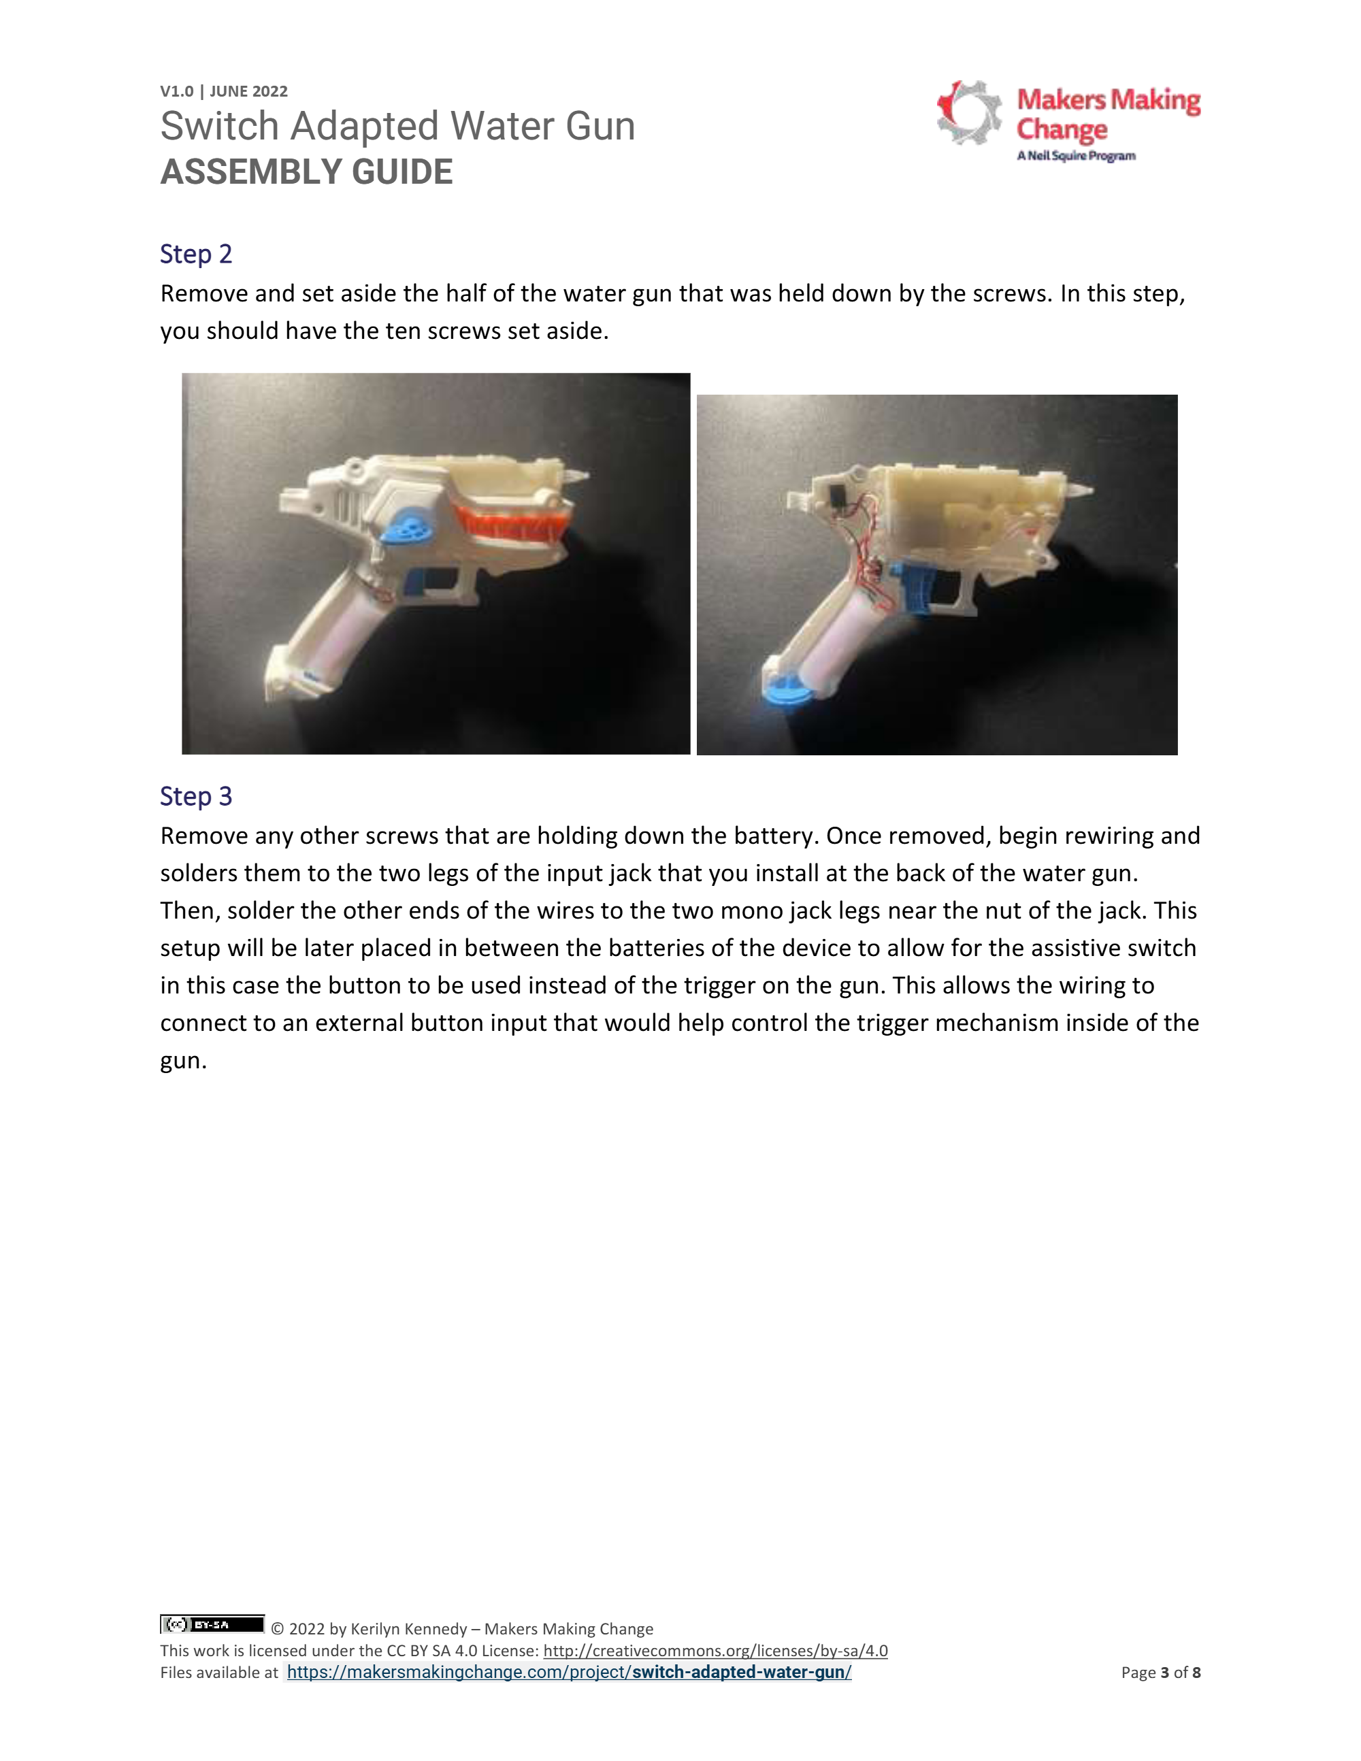The two circled spots drawn on the interior of the water gun is the two electrical portions of the water gun. The one on the top is where we drilled a portion of the gun so that we could add a solder lug switch. There is also a plug in that gets used by the 3D printed button that triggers the bottom circled button which will allow the water to go through the tube and spray out. The bottom button can also be triggered by the water guns trigger when pressed.



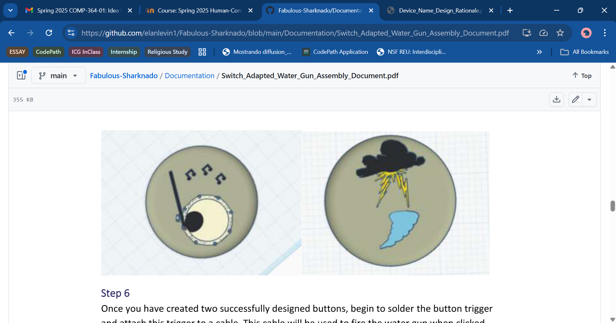This button went through various phases. Initially, we wanted the entirety to look like a cloud on top of the button for it to be very 3D. When trying to design the button to look like a cloud, we went against it due to it looking very peculiar and time constraints. We decided to go with a thunderstorm and tornado due to our name being Fabulous-Sharknado. We made sure to make the images to be slightly higher to give a tactile affect.

# Prototyping

## Squared base

Squared base with two holes and a stand

Physical Component / Enclosure

In Figure 3, we drew a squared base with a cylindrical stand. The base had only one pair of rectangular holes with the purpose of velcro to go through and be wrapped on the users’ arm or arm rest of wheelchair.

Electrical Components

N/A

Code Structure / Function

N/A

## Round base

Rounded base with two holes and a stand

Physical Component / Enclosure

In Figure 4, we drew a cylindrical base with a cylindrical stand. The base had only one pair of rectangular holes with the purpose of velcro to go through and be wrapped on the users’ arm or arm rest of wheelchair. The stand has one rectangular hole that is also meant to have velcro go through, but it is meant to add for more stability.

Electrical Components

N/A

Code Structure / Function

N/A

## Prototype Decisions

|  |  |  |
| --- | --- | --- |
| **Prototype** | **Decision (Abandon, Modify, Proceed)** | **Justification** |
| PROTOTYPE 1 | Modify | Add extra hole in the stand |
| PROTOTYPE 2 | Modify | Make the base rectangular |

# Testing

## Test Methods

1. Velcro strap is adjustable for users
2. Buttons are functional
3. Base allows for enough stability for movement

TEST 1

When the velcro is placed through the holes, does it allow for (1) different arm widths and (2) different arm rest widths?

TEST 2

Buttons are (1) properly soldered, (2) can properly trigger the water gun, and (3) can be used for prolonged time.

TEST 3

If the user has the water gun holder on their arm, can they move their arm without the gun or base falling off or moving around?

Test Results

TEST 1

1. Yes! It was able to be strapped comfortably on thinner and thicker arms.
2. Somewhat. There was not enough velcro to accommodate all wheelchair arm widths. This could be fixed if there was more velcro attached on the ribbon closer to the base.

TEST 2

1. Yes!
2. Yes!
3. Yes!

TEST 3

1. Somewhat. The base would not move, but the gun would slip. This would be fixed by a future iteration of this project.

# Goals Met

The goals we met were:

* Functional button
* Stand is able to stay on arm or arm rest
* Adjustable for arms
* Water themed
* Minimal assistance to place/wear
* Less than $5.00 USD
* Made with basic PLA

The goals not met were:

* Not successfully adjustable for arm rest
* Gun is not fully stable if the stand is on the users’ arm
* Could be lighter

# Opportunities for Improvement

There are multiple ways this stand can be improved, namely due to size and stability with the gun. For the next time this project can be done, we will be leaning to a sleeker design as well as more stable design for the water gun holder. We would also like to have more input given by people who do have mobility constraints and wheelchair users.

Physical Component / Enclosure

The green circled area will have a stronger grip to the water guns neck. The ways we could implement this would be if the half spheres were slightly closer to one another, as well as the arc attached to them to be thicker. This will make the water gun to be more stable, which will allow for more confident and free movements done by the user.



The yellow circled area will be thinner. This will make the stand to be lighter in weight as well as cut down on printing time.

This will allow for the entire water gun stand to appear more stable, but also sleeker. Stability will be important for any user that can have any sudden body movements, the user could be more comfortable using the water gun and avoid any readjustments that would result from these sudden movements.

Electrical Components

Our water gun is very basic in the sense that it uses electricity to shoot the water, and that’s it. In future iterations, we would want to increase the range of motion for people who have the water gun mounted on their wheelchair. That would involve a button that allows for movement to the left and right, as well as up and down. This would mean 4 different buttons and code to go with it.

Code Structure / Function

If we were to make the water gun stand have an increased range of motion, that means we would need to program the stand and its circuits to be moved by a set amount of centimeters/inches or for a set amount of time.